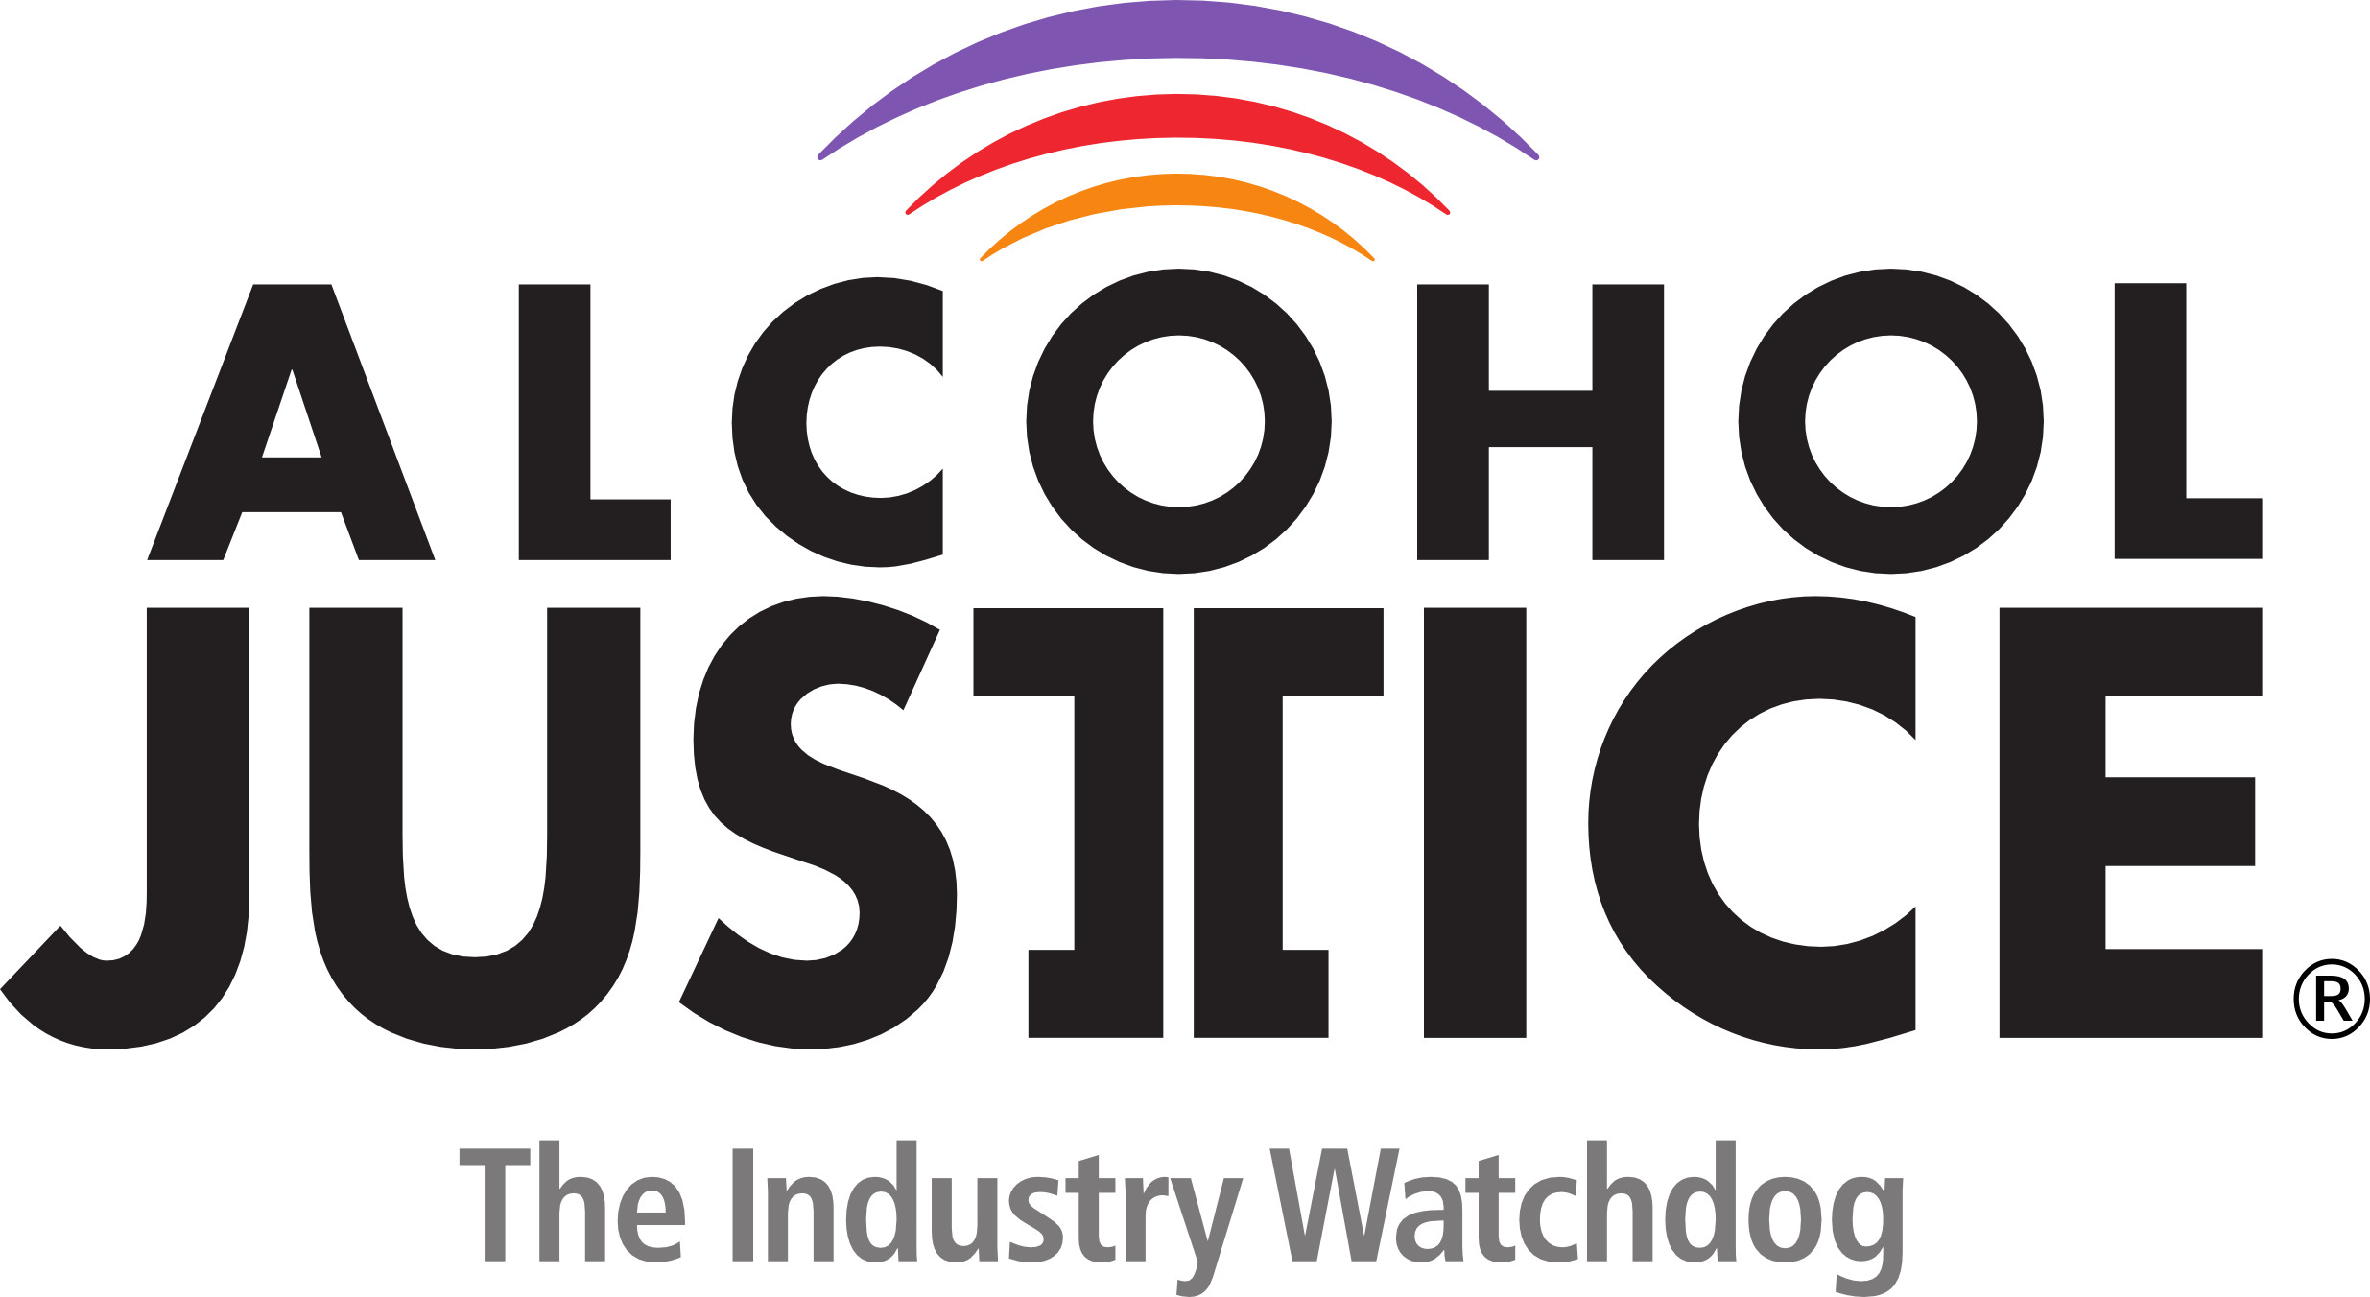

FOR IMMEDIATE RELEASE Contact: Michael Scippa 415 548-0492
Jorge Castillo 213 840-3336

Powerful California Senate Committee Passes SB 819
to Ban Powdered Alcohol

SUPPORT GROWS AMONG PUBLIC HEALTH & SAFETY ORGANIZATIONS

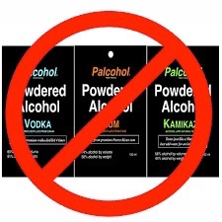
SACRAMENTO, CA (March 8, 2016) – Alcohol Justice and the California Alcohol Policy Alliance (CAPA) are reporting that the first of two proposed bills to ban powdered alcohol in California has been passed by the powerful California Senate Governmental Organization (GO) Committee. “We applaud Senator Huff (R-Diamond Bar), author of SB 819, Senator Hall, Chair of the GO Committee, and all the GO Committee members for their leadership on this issue,” stated Richard Zaldivar, spokesperson for CAPA and Alcohol Justice. “As soon as this bill is passed by the entire legislature and signed by Governor Brown, California will join 28 other states which have already banned the product to protect the health and safety of our young people.”
SB 819, and an identical measure in the Assembly (AB 1554 - authored by Assemblymember Irwin D-Thousand Oaks), will create a comprehensive pre-emptive stop to a chilling litany of health and safety concerns associated with powdered or crystalline alcohol. The bills will prohibit the possession, purchase, sale, offer for sale, distribution, manufacture, or use of powdered alcohol and would make the violation of these provisions punishable with a fine.

An impressive group of public health and safety advocates from across the state have come together to support the legislation including:

- Alcohol Justice
- Alpine County Board of Supervisors
- California Alcohol Policy Alliance (CAPA)
- California College and University Police Chiefs Association (CCUPCA)
- California Council on Alcohol Problems (CALCAP)
- California District Attorneys Association (CDAA)
- California State Sheriffs Association (CSSA)
- Children’s Hospital Los Angeles
- City of El Cajon
- City of Hayward
- Consumer Federation of California (CFC)
- County Health Executives Association of California (CHEAC)
- County of Los Angeles, Office of the Sheriff
- Eden Youth & Family Center
- Friday Night Live
- Health Officers Association of California (HOAC)
- Institute for Public Strategies
- Janus of Santa Cruz
- Los Angeles Drug and Alcohol Policy Alliance (LADAPA)
- Lutheran Office of Public Policy-California (LOPP)
- Marin County Board of Supervisors
- The McGeorge Clinic (UOP McGeorge School of Law)
- Pueblo Y Salud
- San Francisco Board of Supervisors
- Saving Lives Coalition
- The Wall Las Memorias Project
- Youth Leadership Institute (YLI)
- Placer County Board of Supervisors

Last March, Alcohol Justice requested emergency legislative action nationwide and in California in response to news that the U.S. Alcohol & Tobacco Tax & Trade Bureau (TTB) approved labels for the powdered alcohol product, Palcohol. The TTB approval gave a green light to begin marketing it wherever legal. Since then, 28 states have permanently banned powdered alcohol. Two states have enacted temporary one-year statutory bans, and three states are regulating it under existing alcohol statutes.
“We know that every year over 500 underage alcohol-related deaths occur in California, while underage drinking costs the public $3.5 billion,” said Bruce Lee Livingston, Executive Director / CEO of Alcohol Justice. “Today’s unanimous committee vote sends a strong message that California will not allow the dangers that powdered alcohol products would add.”
The bill passed today on a 12-0 vote and will now move through one more committee before being voted upon by the full Senate.
For more information: http://alcoholpolicyalliance.org/
To TAKE ACTION: http://bit.ly/1x1qvbT

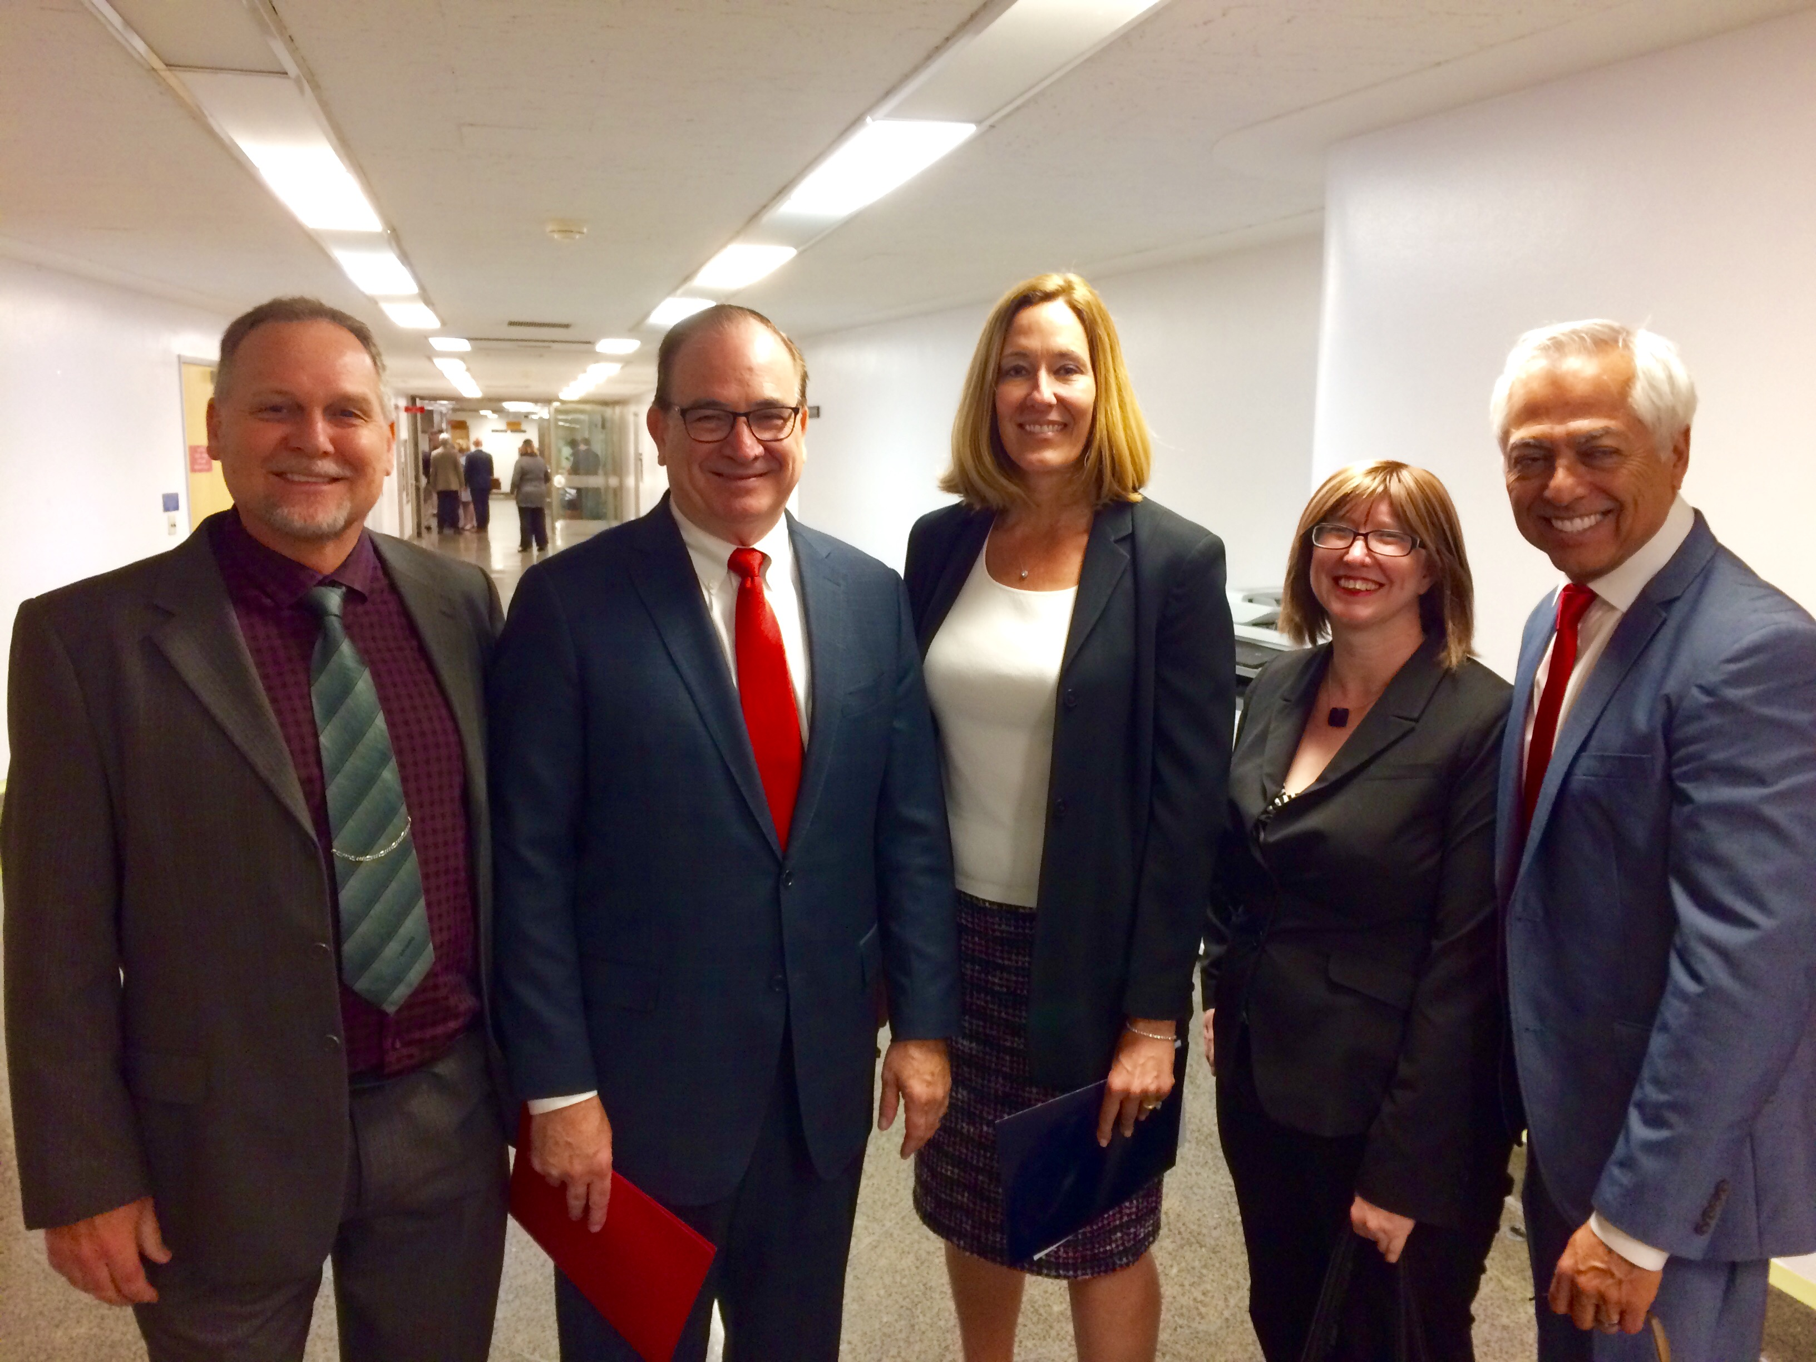
SB 819, to ban powdered alcohol in California has been passed by the Senate Governmental Organization Committee. After the hearing, left to right - Bruce Lee Livingston, E.D./CEO of Alcohol Justice, Senator Bob Huff, Author of SB 819, Assembly Member Jacqui Irwin, Author of AB 1554, a companion bill in the Assembly, Kat DeBurgh, E.D. of the Health Officers Association of California, & Richard Zaldivar, Founder & Director of The Wall Las Memorias Project and Co-Chair of the California Alcohol Policy Alliance (CAPA). (Photo by Michael Scippa)
###

