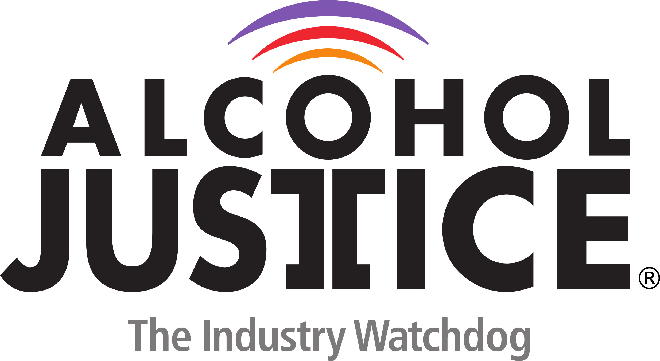

MEDIA ADVISORY CONTACT: Michael Scippa 415 548-0492
For events occurring August 26, 2014 Jorge Castillo 213 840-3336

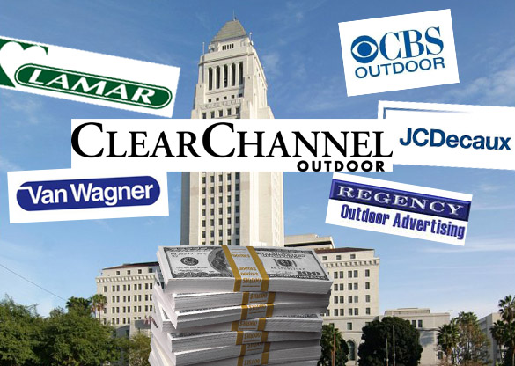
Photo by Dennis Hathaway

Despite Massive Lobbying by Clear Channel and JCDecaux,
Coalition to Ban Alcohol Ads on Public Property in Los Angeles Urges City Planning and Land Use Management Committee
to Say No to Outdoor Alcohol Ads at LAX

Committee Hearing on the Issue Takes Place Tuesday
Public Urged to TAKE ACTION

LOS ANGELES, CALIFORNIA (August 25, 2014) – The Coalition to Ban Alcohol Ads on Public Property in Los Angeles (www.NoAlcoholAds.org) will be present tomorrow at the City Planning and Land Use Management Committee (PLUM) hearing to demand that the newly proposed LAX outdoor sign district not include alcohol ads.

“In the dying days of summer, JCDecaux, Clear Channel and their lobbyists, think they can sneak this measure through with nobody watching and no opposition,” stated Jorge Castillo, Advocacy Director at Alcohol Justice and member of the Coalition to Ban Alcohol Ads on Public Property in Los Angeles. “We may not have their spending budget but we have the endorsement of the community. To protect the public health and safety of L.A. residents and visitors, we’ll urge the PLUM committee to just say NO to outdoor alcohol ads at LAX.”

The public is encouraged to TAKE ACTION – Click here http://bit.ly/1tIBuka to tell the PLUM Committee – NO OUTDOOR ALCOHOL ADS AT LAX.

According to official reports from the City Ethics Commission, in just the first six months of 2014, JCDecaux has spent $190,000 lobbying to secure city advertising contracts and to make sure alcohol ads are not excluded from contracts covering LAX. The firms they paid to lobby on their behalf include: Englander, Knabe & Allen, Ek & Ek, and Molina Consulting. JCDecaux has the current LAX indoor advertising contract.

In addition, Clear Channel in the first six months of 2014 has spent $ 241,000 lobbying to secure city advertising contracts and insure that alcohol ads would not be excluded from any contract.

"Money should never be part of this discussion. It is very dangerous. Young people that see those signs suffer great harm in their lives from the use of alcohol," stated Kitty Dukakis, a coalition supporter.

What: Los Angeles City Planning and Land Use Management Committee Hearing
When: Tuesday, August 26, 2014 2:30 P.M.
Where: Room 350, L.A. City Hall, 200 North Spring St., Los Angeles, CA 90012

Why:
- The sign district would allow almost 300,000 sq. ft. of new off-site advertising on terminal buildings and parking structures. That includes almost 40,000 sq. ft. of digital displays with brightly-lit, changeable messages.
- Alcohol is an estimated $116 billion-per-year industry in the U.S., and underage drinkers are responsible for 20% of all alcohol consumed and for 19% (or $22.5 billion) of alcohol industry revenues.
- Advertisements promoting alcoholic beverages are pervasive, and oversight is left to ineffective self-regulation by the alcohol industry.
- A 2006 study that found reductions in alcohol advertising could produce declines in adolescent alcohol consumption (e.g., a 28% reduction in alcohol advertising would reduce adolescent monthly alcohol participation from 25% to between 24 and 21%, and binge drinking from 12% to between 11 and 8%).
- Despite claims of economic necessity, revenue from alcohol ads comprises less than 1% of reporting agencies’ operating revenue
- Last December, UCLA, Center for Alcohol Marketing to Youth, & Dr. Jonathan Fielding submitted clear and compelling evidence that alcohol advertising on city owned property encourages youth

The Coalition to Ban Alcohol Ads on Public Property in Los Angeles is a grassroots effort.

Coalition members include:

American Indian Movement – WEST
Alcohol Justice
Asian American Drug Abuse Program Inc.
Boyle Heights Stakeholders Association
Coalition to Ban Billboard Blight
Community Coalition
Institute for Public Strategies
Koreatown Youth & Community Center
Mexican History Foundation
Mothers of East L.A. (MELA)
Personal Involvement Center, Inc.
P3 Partnership for a Positive Pomona
Phoenix House
Pillar of Fire Church & School
Paso por Paso
Pueblo y Salud
Saving Lives Drug and Alcohol Coalition
Sycamore Grove School
Tarzana Treatment Centers & AWARE Coalition
T.R.E.A.T Advocacy & Support for Recovering Individuals
The Wall Las Memorias Project
United Coalition East Prevention Project
Woman’s Christian Temperance Union of Southern California
Women Against Gun Violence
Writers In Treatment

Supporters include:

Michael & Kitty Dukakis, former Massachusetts Governor & First Lady
Boyle Heights Neighborhood Council
California Council on Alcohol Problems
California Alliance for Retired Americans
California Hispanic Commission on Alcohol and Drug Abuse
Center for Living and Learning
Church of the Resurrection
County Alcohol and Drug Program Administrators’ Association of California
Crescenta Valley Drug & Alcohol Prevention Coalition
Cri-Help
David H. Jernigan, Ph.D. Director Center on Alcohol Marketing and Youth
Day One Pasadena
Dr. J. Benjamin Hardwick
Ernest P. Noble, Ph.D., M.D. Director of the UCLA Alcohol Research Center
Jonathan E. Fielding, M.D., M.P.H Director & Health Officer County of Los Angeles Public Health
Jerry L. Grenard, Ph.D. School of Community and Global Health Claremont Graduate University
Jeremy T. Goldbach, Ph.D., LMSW USC School of Social Work
Kurtwood Smith, actor
Monsignor John Moretta
National Council on Alcoholism & Drug Dependence East San Gabriel & Pomona Valleys
Public Citizen
Resurrection Church Neighborhood Watch – Los Angeles
San Fernando Valley Partnership
Venice Neighborhood Council
Wesley L. Ford, M.A., M.P.H. Director Substance Abuse Prevention and Control

For More Information go to: www.AlcoholJustice.org and www.NoAlcoholAds.org





