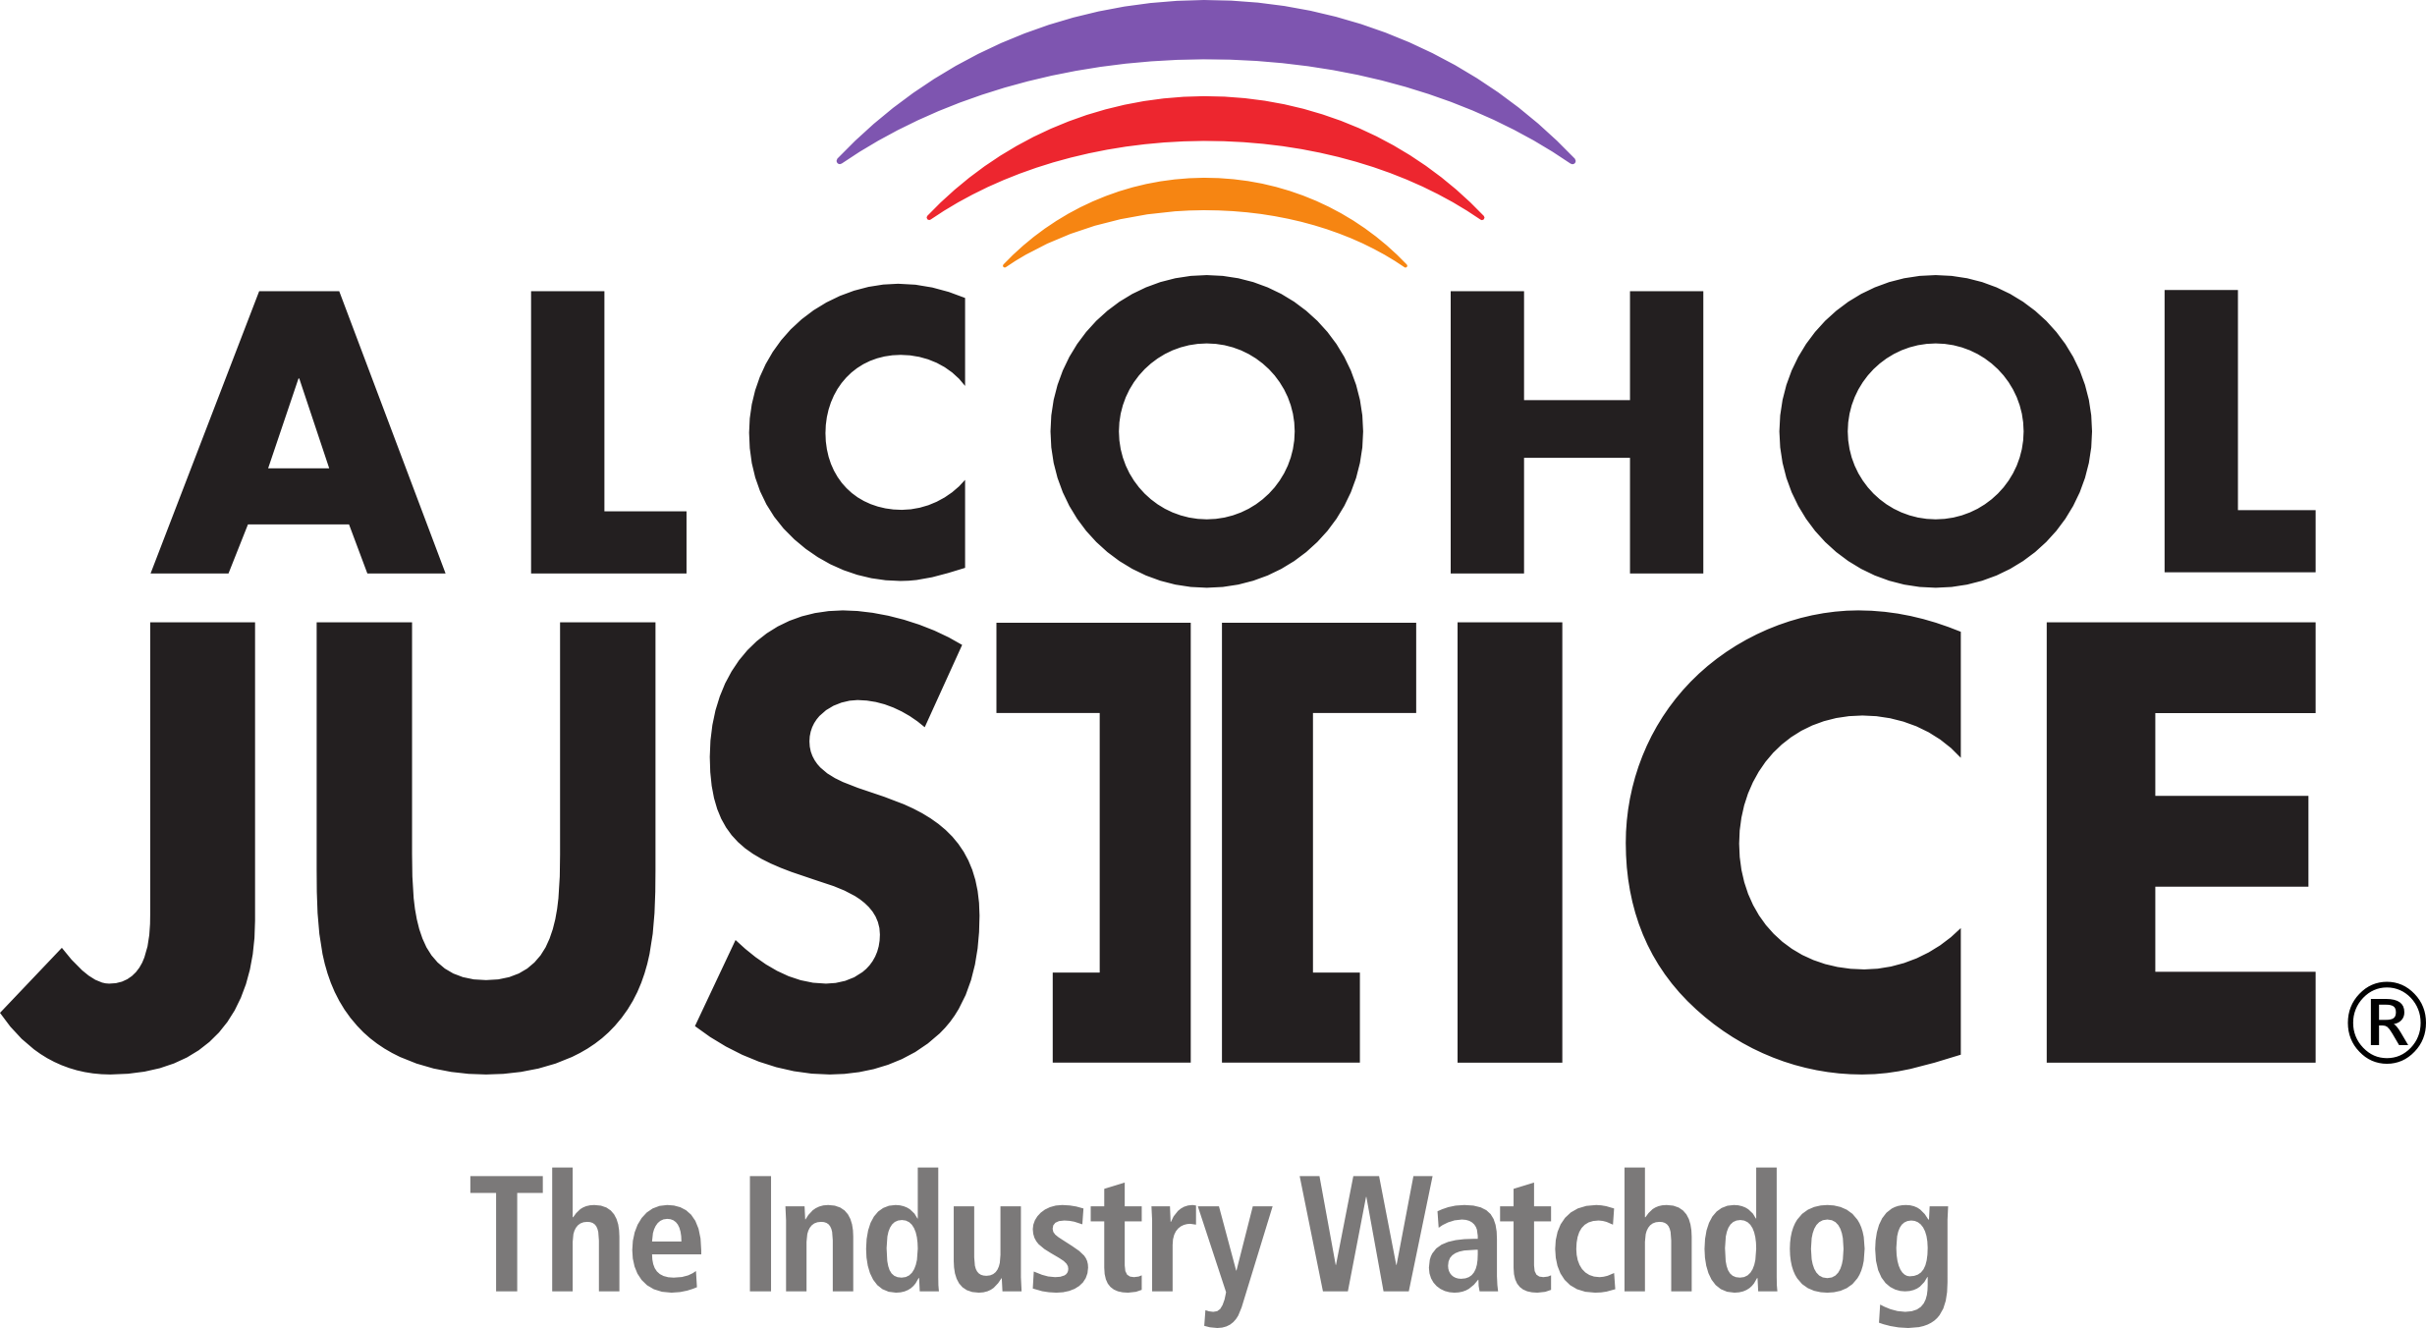

FOR IMMEDIATE RELEASE Contact: Michael Scippa 415 257-2490
Jorge Castillo 213 840-3336

Six Premieres Among 18 Great Films at the 2nd Annual REEL Recovery Film Festival & Symposium – San Francisco & San Rafael, California
June 11-14, 2015 - Tickets Available Now

SAN FRANCISCO, CALIFORNIA (June 2, 2015) – San Rafael-based Alcohol Justice and Studio City-based Writers In Treatment announced today that there would be six exciting film premieres at the 2nd Annual REEL Recovery Film Festival & Symposium– San Francisco Bay Area Edition. A total of 18 select feature-length and short, fictional and factual alcohol and drug addiction-themed films will be presented over four days in 14 sessions at two locations with a goal of engaging audiences with honest stories about the disease as well as the hope and opportunity for recovery. There will be expert panel discussions following most of the sessions.

The festival opens at the New People Cinema on Thursday June 11, 2015, with the San Francisco premiere of a true story, Girl on the Edge, starring Peter Coyote. The film follows the journey of a young girl struggling with the aftermath of a horrific trauma, the toll that it takes on her family and the last chance she has to overcome it in the most unlikely of places. A post-screening Q&A will take place with Producer/Director Jay Silverman, and actor Mackenzie Phillips. Immediately following there will be a VIP Reception at the Hotel Kabuki with live music by singer/songwriter Elizabeth Edwards.

On Friday morning June 12, 2015, at the Smith Rafael Film Center in San Rafael, a world premiere, “director’s cut” of Kids Are Dying will be screened. The documentary is about drug overdose and the overdose death epidemic in New Jersey which is worse than it has ever been in history. Heroin, and misused and abused prescription pain medication are killing more people than car crashes. Parallels to problems in the Bay Area will be explored in a following panel discussion featuring Matt Willis, MD, MPH Marin County Public Health Officer, Mark Dale, Founder, Families 4 Safer Schools, Jennifer Golick, Clinical Director, Muir Wood Adolescent and Family Services, and Michael DeLeon, Producer/Director of Kids Are Dying.

DeLeon will also present the West Coast premiere of his new documentary An American Epidemic on Friday, June 12, 2015, at 6 P.M. at the New People Cinema in San Francisco. This documentary presents a national perspective on drug misuse and outlines REAL solutions that will solve the problem but only if there is REAL collaboration. “This is going to take EVERYONE, Working Together, to end this crisis,” said DeLeon.

Actor/Writer/Director Daniel Baldwin's acclaimed new film The Wisdom to Know the Difference will also have its San Francisco premiere on Friday on Friday, June 12, 2015, at 8 P.M. at the New People Cinema in San Francisco. WISDOM is a story about a man's journey to bring his sobriety full circle and help a young girl kick a serious drug problem by kidnapping and secluding her in a desolate cabin. The film starring Baldwin, Lou Diamond Phillips, Mayra Leal, Maggie Wagner and William “Billy” Baldwin, is based in part on actual events.

The San Francisco premiere of two brilliant short films will take place on Saturday, June 13, 2015, at the New People Cinema. Director KT Curran’s The Holding Cell, is about one teenage girl's free-fall into the harrowing world of prescription drug abuse and addiction. Producer Lisa Brandy will present the film which is based upon true stories about real teenagers in Sarasota, Florida.

The second short film, Easy Silence, directed by Stephen Anthony Bailey, is the tale of a young woman in the backwoods of the American south who suddenly finds herself a single mother battling past addictions and demons that threaten the future of her and her baby.

Alcohol Justice and Writers In Treatment are producing the event with generous support from the San Francisco Sheriff's Department, Duffy's Napa Valley Rehab, Center Point, Inc., West America Bank, Kaiser Permanente Community Benefits Programs - Marin/Sonoma Area, Marin County Mental Health Substance Use Services, Ghilotti Construction Company, KRON-TV, the Michael Basso Foundation, Muir Wood Adolescent and Family Services, KPOO-FM, North Bay Recovery Center, Hotel Kabuki, Book Passage Book Store, and many Bay Area individuals and families.
“The REEL Recovery Film Festival helps to bring alcoholism and addiction out of the closet,” stated Michael Scippa, festival director. “Our goal is to reduce the stigma, and raise public awareness that it is not a moral failing but a devastating disease that, like other potentially fatal diseases, requires specialized treatment.”
Tickets are available exclusively through BrownPaperTickets.com. For more information about the festival, and to view a PSA featuring Michael Pritchard, go to: FilmFestSFBay.org “The ticket price for most of the sessions is just $10,” stated Scippa. “But if there are seats available we’ll allow anyone admittance regardless of their ability to pay.”
For media availability of filmmakers please contact Michael Scippa at 415 257-2490 or michaels@alcoholjustice.org


###

