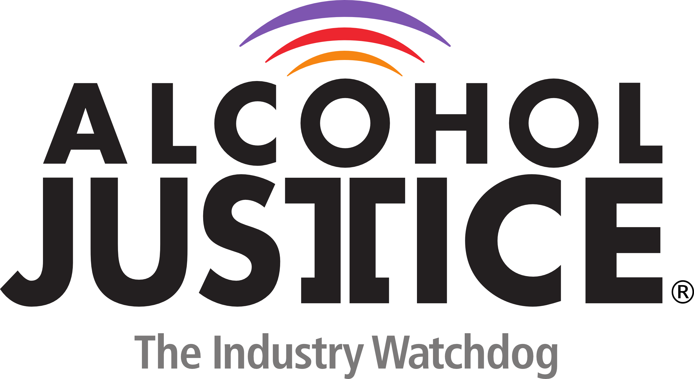

FOR IMMEDIATE RELEASE Contact: Michael Scippa 415 548-0492
Jorge Castillo 213 840-3336

Nicole Boxer In Person to Present Her Film “HOW I GOT OVER” at the 2nd Annual
REEL Recovery Film Festival & Symposium, San Francisco Bay Area

June 12-14, 2015 Marin Schedule also includes a World Premiere of Kids Are Dying,
and a Robin Williams Tribute

SAN FRANCISCO, CALIFORNIA (June 4, 2015) – San Rafael-based Alcohol Justice and Studio City-based Writers In Treatment announced today that Nicole Boxer will be appearing at the screening of her feature-length documentary HOW I GOT OVER at 10 A.M., June 13, 2015 at the Smith Rafael Film Center in San Rafael.

The film follows 15 formerly homeless women as they craft an original play, based on their harrowing true-life stories, to be performed one-night-only at The Kennedy Center.
Guided by teachers from the Theatre Lab School of the Dramatic Arts, the women of N Street Village - a community for addiction recovery - discover their untapped artistic talents and reckon with their traumatic histories. Sharing their pasts to release the potential in their futures, the emboldened women take the stage before a packed house, illuminating the transformative power of arts education.

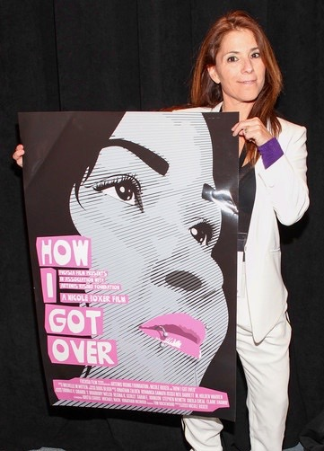
“I made this film because I believe a connective power exists between a filmmaker and a subject, and between one who is willing to testify and one who bears witness--- and I want to see how much farther that connection can go to make positive change in the world,” Boxer has stated. “ What I did not foresee when I began filming HOW I GOT OVER is how much I have in common with the ladies of N Street, despite our surface disparities. Our stories are now forever entwined.”

The screening will be followed by a conversation between filmmaker Nicole Boxer and Dr. Sushma Taylor, CEO, Center Point, Inc.

“The REEL Recovery Film Festival celebrates film, the arts, writing and creativity,“ stated Michael Scippa, Director of Public Affairs for Alcohol Justice. “We are grateful to showcase filmmakers like Nicole Boxer, who are making honest films about addiction, alcoholism, behavioral disorders, treatment and recovery. One of our goals, besides reducing the stigma of substance misuse and treatment, is to engage, empower, and activate the recovery community as a powerful advocacy constituency.”
On Friday morning June 12, 2015, at the Smith Rafael Film Center in San Rafael, a world premiere, “director’s cut” of Kids Are Dying will be screened. The documentary is about drug overdose and the overdose death epidemic in New Jersey. Heroin, and misused and abused prescription pain medication are killing more people than car crashes.

Parallels to problems in the Bay Area will be explored in a following panel discussion featuring Matt Willis, MD, MPH Marin County Public Health Officer, Mark Dale Founder, Families 4 Safer Schools, Jennifer Golick Clinical Director, Muir Wood Adolescent and Family Services, and Michael DeLeon, Producer/Director of Kids Are Dying.

There will be a special Tribute to Robin Williams on Sunday morning June 14, 2015, at the Smith Rafael Film Center in San Rafael, with a screening of Patch Adams. The film, starring Robin Williams & Philip Seymour Hoffman, tells a true story about a medical student in the 1970’s who treats patients, illegally, using humor. Bay Area comedian Johnny Steele, a good friend of the late Williams, will introduce the session.
The 2nd Annual REEL Recovery Film Festival & Symposium – San Francisco Bay Area Edition will present 18 select feature-length and short, fictional and factual alcohol and drug addiction-themed films over four days in 14 sessions at two locations with a goal of engaging audiences with honest stories about the disease as well as the hope and opportunity for recovery. There will be expert panel discussions following most of the sessions.

Alcohol Justice and Writers In Treatment are producing the event with generous support from Duffy's Napa Valley Rehab, the San Francisco Sheriff's Department, Center Point, Inc., West America Bank, Kaiser Permanente Community Benefits Programs - Marin/Sonoma Area, Marin County Mental Health Substance Use Services, KRON-TV, the Michael Basso Foundation, Muir Wood Adolescent and Family Services, KPOO-FM, North Bay Recovery Center, Hotel Kabuki, Book Passage Book Store, Ghilotti Construction Company, and many Bay Area individuals and families.
The festival opens at the New People Cinema on Thursday June 11, 2015, with the San Francisco premiere of a true story, Girl on the Edge, starring Peter Coyote. The film follows the journey of a young girl struggling with the aftermath of a horrific trauma, the toll that it takes on her family and the last chance she has to overcome it in the most unlikely of places. A post-screening Q&A will take place with Producer/Director Jay Silverman, and actor Mackenzie Phillips. Immediately following there will be a VIP Reception at the Hotel Kabuki with live music by singer/songwriter Elizabeth Edwards.

Tickets to all screenings and symposiums are available exclusively through BrownPaperTickets.com. For more information about the festival, and to view a PSA featuring Michael Pritchard, go to: FilmFestSFBay.org “The ticket price for most of the sessions is just $10,” stated Scippa. “But if there are seats available we’ll allow anyone admittance regardless of their ability to pay.”
For media availability of filmmakers please contact Michael Scippa at 415 548-0492 or michaels@alcoholjustice.org


###

